NIIT UNIVERSITY, NEEMRANA

B. TECH. COMMUNITY CONNECT

COMPREHENSIVE REPORT / REVIEW ARTICLE

SEMESTER: SECOND SEMESTER SESSION: 2016-2017

COURSE NO.: NU 112

COURSE TITLE: EACH ONE TEACH ONE

Community Connect (NU 112) is an audit course in SEMESTER II at NIIT UNIVERSITY, NEEMRANA, RAJASTHAN. I, AJINKYA BEDEKAR, as a student of SEMESTER II, undertook this course with great enthusiasm. It was a great fun to visit a nearby government school and teach those subjects to the students in which they have problems.

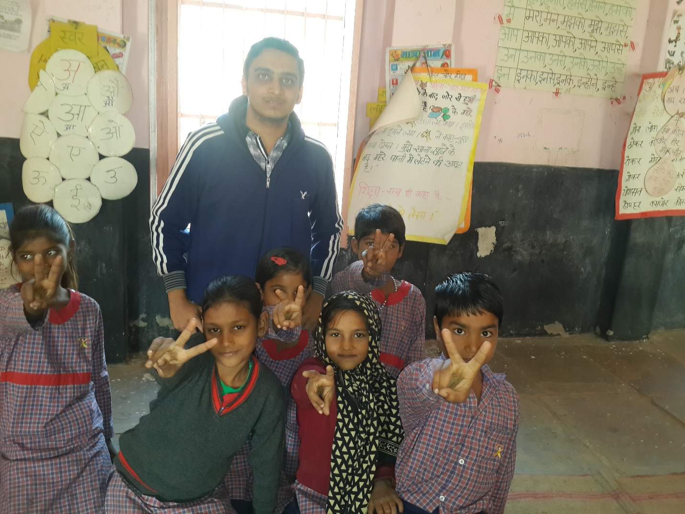

At first, very less students of NIIT UNIVERSITY were interested for this course as the visit was to be done on Saturdays, so most students thought it of no use to hamper their Saturday holiday. But, with the guidance of Dr. Anshima Prakash Srivastava madam and Sushmita Singh madam, everybody got energy to help the students who are really in need.

We had 4 visits to schools of Kali Pahari and Majrakath. It was a great time that we spent with the students there. We had a very nice conversation. Those students were also very much comfortable with us. Without hesitating, they were asking us doubts and asking us to teach the subjects in which they had problems.

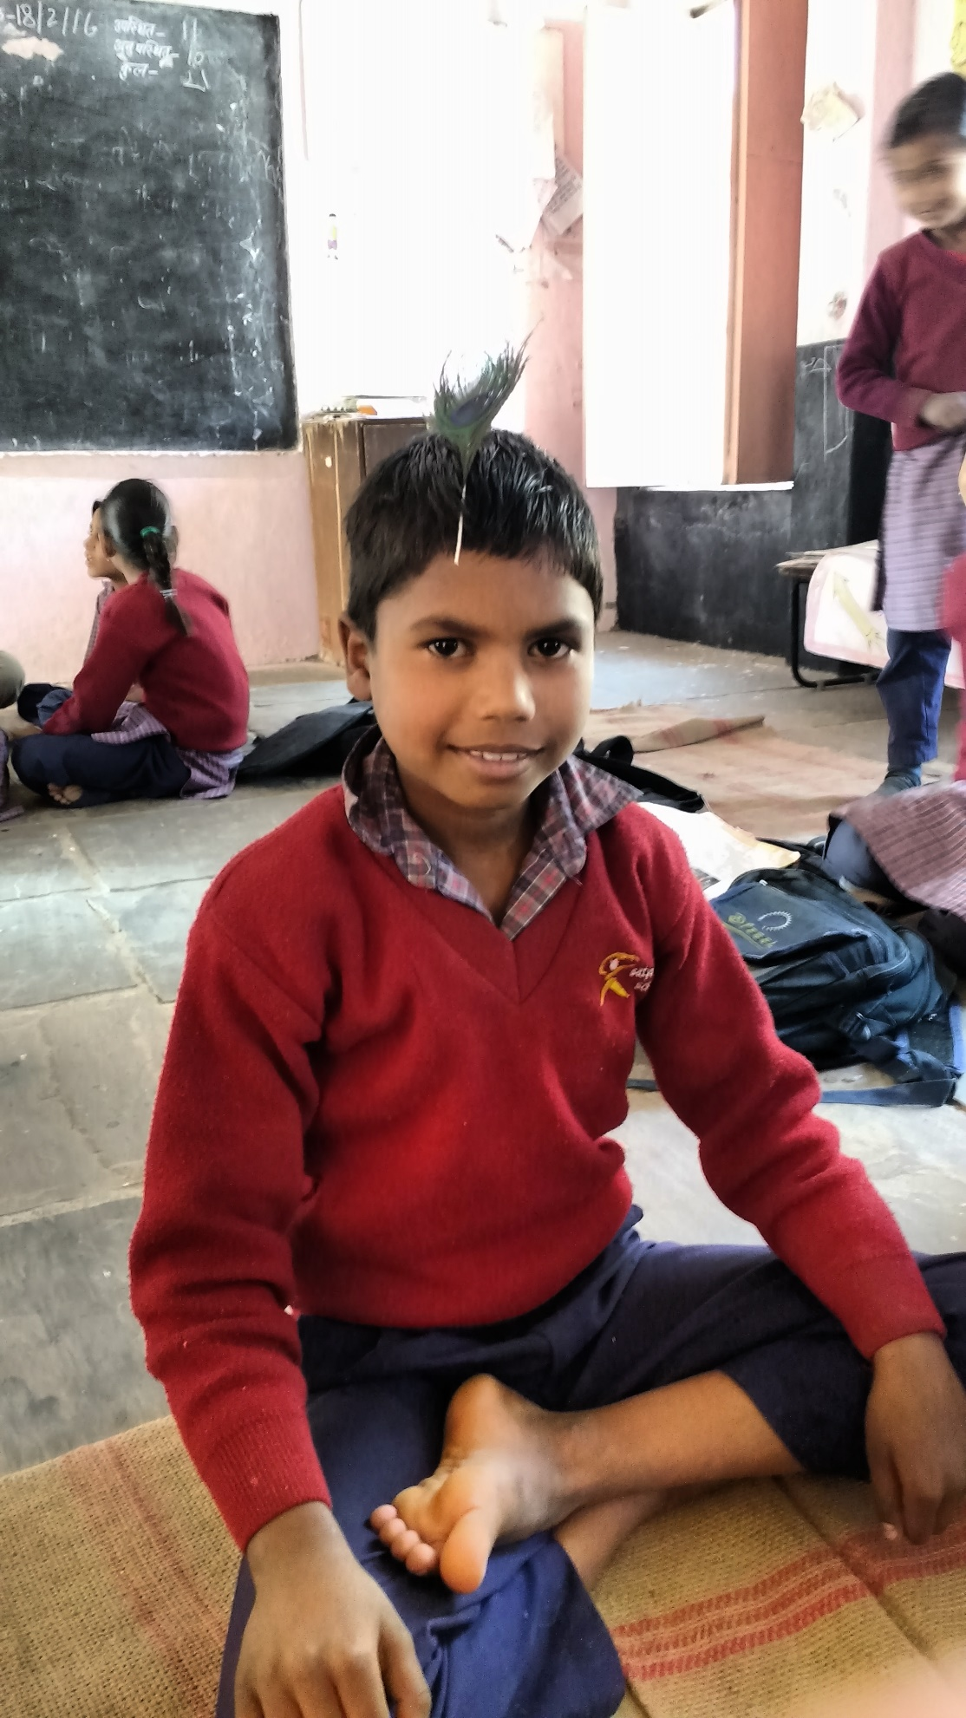

We all had great fun. We played a lot of games with them. We saw a dedication and enthusiasm in them for studies in spite of their financial problems. They come from long distances to study in schools. We saw how they enjoy in school’s playground, how happy they are during Mid-Day Meals. They are very much disciplined. Even, before taking meals, they sing prayers.

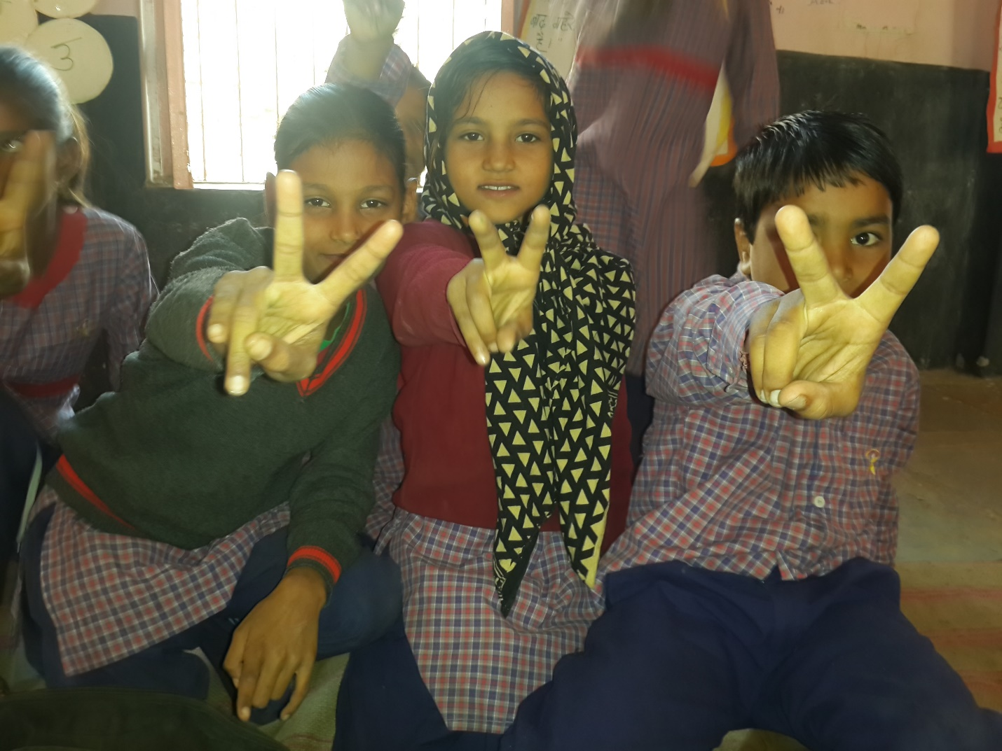

Our last visit was to Parle Biscuits Pvt. Ltd. It was also a great time there. At first, we saw an animation movie which showed about the history of Parle. Then, it was the activity time which was full of fun and enjoyment. Then, we saw how the products of Parle are manufactured.

At all, the COMMUNITY CONNECT course was full of fun, joy, enjoyment, and knowledge. We learnt a lot of things from this course. By teaching students, we had an experience of teaching. By visiting Parle, we came to know how our favorite biscuits and candies are manufactured.